May 12, 2021

Subject: Bid No. 9051.9, Athletic, Cheerleader, and Pom Pon Uniform

This is Amendment Number 1.

In accordance with the terms of the above-mentioned contract, this is authorization to extend this contract, through May 12, 2022. All terms and conditions remain the same.

Supplier(s):

All American Sports Corp.
Varsity Brands Holding Co., Inc.

COMMENTS:

Contract Summary Attached

REFER QUESTIONS TO: Julie Johnson, Buyer, 301-279-3306

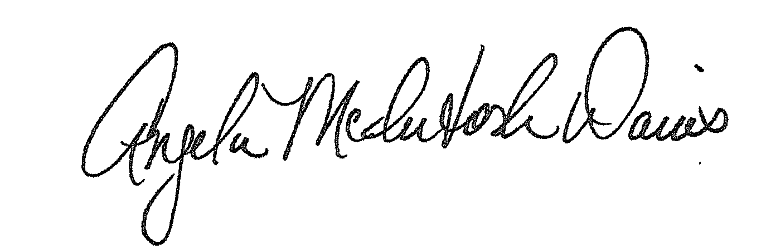

Approved:
Angela McIntosh-Davis, CPPB, Team Leader, Procurement Unit

AMD:jej

Distribution: Supplier(s); Bid File

